Certificate

This is to certify that this report embodies the original work done by

***Chitrankana Bhowmik***

during this project submission as partial fulfilment of the requirement for the project of BSC (Computer Science) 6th semester of G.C College, Silchar.

Signature of Guide Signature of HOD

Signature of External Invigilator

declareation

Acknowledgement

The satisfaction that accompanies the successful completion of any task would be incomplete without the mention of people whose ceaseless cooperation made it possible, whose constant guidance and encouragement crown all efforts with success.

I am grateful to my project guide Prof. Dipanjali Paul Ma’am for the guidance, inspiration and constructive suggestions that helped me in the preparation of this project.

I also thank my colleagues who have helped in successful in completion of the project.

***Chitrankana Bhowmik***

Abstract

Thoughts and Words is a mini website developed for people to share their words and thoughts in the form of posts, written and read by the people of the particular website-community. It aims at creating a fresh, hassle-free space for people to interact and propagate their ideas. Along with that, it is made for writers to pen their works and share it with the rest of the community in a user-friendly platform.

INDEX

|  |  |  |
| --- | --- | --- |
| CHAPTER NO. | CHAPTER NAME | PAGE NO. |
| 1 | Introduction |  |
| 2 | The Overall Description |  |
| 3 | System Analysis |  |
| 4 | Requirement Specifications |  |
| 5 | Technology and UI Frame |  |
| 6 | Software Description |  |
| 7 | Screenshots |  |
| 8 | Project Description |  |
| 9 | System Maintenance |  |
| 10 | Conclusion |  |

CHAPTER 1: INTRODUCTION

* 1. ***Definition :-***

Thoughts and Word is developed for writers and readers to meet at a point. It facilitates to access the account links of a particular writer.

* 1. ***Purpose :-***

The purpose of developing Thoughts and Words is to make a user-friendly website for hazel-free loving users. Another purpose for developing this website is to keep track of the writer’s write-ups.

* 1. ***Scope :-***

It is a 3-tier architecture that allows us to maintain the hosting on one server and database server and any user can use it in any operating system using any browser available. The scope is very wide and opened as there are no limitations on accessing the system.

* 1. ***Overview* :-**

Thoughts and Words basically is based on user account system that allows an user to write, read, comment, like posts of other users. Non – Registered users can also view the posts but in no way they can write or comment or like any post.

It also has three different modes of post view which are public, private, protected.

Chapter 2: The overall description

2.1 Product Perspective :-

The product Thoughts and Words is an independent website and does not depend on any other product or system. The website will automate various task associated with handling writer’s details and better organizing the stored information thus helping the readers to ensure smooth reading. Its features include a space for independent accounts made by the consumer, a space for posting their write-ups and/or thoughts in accordance with the category (alias *genre*) of their own making or choosing from the various lists input by other users. It also includes the latest features of connecting one’s account with their respective social media accounts, for better promotion. The website is constructed keeping user accessibility to the smoothest in mind.

2.2 Product Functions :-

Our system has one type of accessing mode for now:

* 1. User

There are two modes of users :

**Writer :** A writer, by creating an account, can post his ideas and/or write-ups through the posts. Also, the writer has the freedom to scroll through posts of other writers, in the process, indulging in virtual interaction with other writers and/or readers through the *comments* features

**Reader :** A reader has the capacity of reading the content created by the writers without creating any account but can’t access features like *like* and *comment*. In brief, an guest entity, without any particular identity attached to the website is to be referred to as the reader.

2.3 Constraints :-

Interface is only in English; no other language option is available as of now. However, audio files or any kind of files related to post can be uploaded in any language of want and posted in the forum. User can login with his /her assigned credentials. However, a guest may view the posts in the website but can’t interact with the said writers/other readers of the posts.

Chapter 3: system analysis

3.1 Introduction :-

Analysis can be defined as breaking up of any whole so as to find out their nature, function etc. It defines design as to make preliminary sketches of to sketch a pattern or outline for plan. To plan and carry out especially by artistic arrangement and the skilful wall. System analysis and design can be characterized as a set of techniques and processes, a community of interests, a culture and an intellectual orientation. The various tasks in the system analysis include the following :

1. Understanding Application.
2. Planning.
3. Scheduling.
4. Developing candidate solution.
5. Performing trade studies.
6. Performing cost benefit analysis.
7. Recommending alternate solutions.
8. Supervising, installing and maintaining the system.

This system manages to the analysis of the problems faced while sharing some good quotes, or essays or some writings with others. This project will help the users to share their writings in an automated convenient way so that it can reach many users in a short span of time and it also allows an user to get feedback on their writings in the form of comments and likes and to which the author of the post can reply to a particular comment on a post to show gratitude towards the commenter.

3.2 Existing System :-

Existing system is a manual way to share the writings and thoughts which includes sharing via post, mails, print media where a viewer cannot like or comment or in other words cannot show their reaction to a post written. It’s a very hard way to reach to many viewers and it takes huge amount of time to reach to a large amount of audience.

3.3 Proposed System :-

To overcome the drawback of the existing system, the proposed system has been evolved. This project aims to reduce the paper work and saving time to share the writings an thoughts. The system provides with the best user interface and an easy and convenient way to share such writings and thoughts in a modern way with use of latest technologies.

***Advantages of Proposed System :***

It is trouble-free to use. It is a relatively fast approach to share writings and thoughts and is highly reliable, approximate result from user interface and efficient reports.

3.4 Feasibility Study :-

Feasibility analysis begins once the goals are defined. It start by generating broad possible solutions, which are possible to give an indication of what the new system should look like. This is where creativity and imagination are used. Analyst must think up new ways of doing things generate new ideas’ There is no need to go into the detailed system operation yet. The solution should provide enough information to make reasonable estimates about project cost and give users an indication of how the new system will fit into the organization. It is important not to exert considerable effort at this stage only to find out that the project is not worthwhile or that there is a need significantly change the original goal. Feasibility of a new system means ensuring that the new system, which we are going to implement, is efficient and affordable. There are various types of feasibility to be determined. They are :

**3.4.1 *Economic Feasibility :***

Development of this website is highly economically feasible. The only thing to be done is to provide the sever rent. It is cost effective in the sense that has eliminated the paper work completely also as of now it is free for users.

**3.4.2 *Technical Feasibility :***

The technical requirement for the system is to have an internet connection, any web browser, mandatory email account and a user account.

**3.4.3 *Operational Feasibility :***

The system work is quite easy to use and learn due to its simple but attractive interface. Users requires no special trainings for operating the system. Technical performance include issues such as determining whether the system can provide the right information for the user at a particular time, and whether the system can be organized so that it always delivers this information at the right place and on time using internet services.

Chapter 4: Requirement specifications

4.1 Hardware Requirements :-

**RAM :** 2 gb

**Hard Disk :** 500 mb

**Processor :** Quad core 1.2 ghz onwards

4.2 Software Requirements :-

**Operating System :** Windows 7 onwards, Mac OS, Linux, Ubuntu, etc..

4.3 Functional Requirements :-

Thoughts and Words involves the following functions :

Easily track of post published with three different modes of view, like, new post, comments, user account view and view user by social media links.

4.4 Non-Functional Requirements :-

**4.4.1 Performance :**

Easy tracking of record and updating can be done. All the requirements relating to performance characteristics of the system are specified in the section below. There are two types of requirements.

Static Requirements do not impose any constraints on the execution characteristics of the system. They are :

1. **Number Of Terminals :**

The software makes use of any underlying database that will reside at the server, while the front end will be available online to the all users via web browsers

1. **Number of Users :**

The number of users vary, as this website finds applications in almost all types of writers

**4.4.2 Availability :**

The software will available to everyone over the internet if hosted on some server online.

**4.4.3 Security :**

The security requirements deal with the primary security. The website should be handled only by the administrator and authorized users. Only authorized user can access the system with username and password.

4.5 Design Constraints :

This software provides security. The login form prevents the system from being misused by unauthorized users. Only an authorized operator will be granted rights to modify as per requirements. This software is also reliable and fault tolerant. The system developed is designed to handle invalid input. Since reliability is major area of concern the system has a backup to avoid data loss. The user should know the programming language very well that it is used to develop software.

CHAPTER 5: Programming

5.1 HTML

**Hypertext Markup Language** (**HTML**) is the standard [markup language](https://en.wikipedia.org/wiki/Markup_language) for documents designed to be displayed in a [web browser](https://en.wikipedia.org/wiki/Web_browser). It can be assisted by technologies such as [Cascading Style Sheets](https://en.wikipedia.org/wiki/Cascading_Style_Sheets) (CSS) and [scripting languages](https://en.wikipedia.org/wiki/Scripting_language) such as [JavaScript](https://en.wikipedia.org/wiki/JavaScript).

[Web browsers](https://en.wikipedia.org/wiki/Web_browser) receive HTML documents from a [web server](https://en.wikipedia.org/wiki/Web_server) or from local storage and [render](https://en.wikipedia.org/wiki/Browser_engine) the documents into multimedia web pages. HTML describes the structure of a [web page](https://en.wikipedia.org/wiki/Web_page) [semantically](https://en.wikipedia.org/wiki/Semantic_Web) and originally included cues for the appearance of the document.

[HTML elements](https://en.wikipedia.org/wiki/HTML_element) are the building blocks of HTML pages. With HTML constructs, [images](https://en.wikipedia.org/wiki/HTML_element#Images_and_objects) and other objects such as [interactive forms](https://en.wikipedia.org/wiki/Fieldset) may be embedded into the rendered page. HTML provides a means to create [structured documents](https://en.wikipedia.org/wiki/Structured_document) by denoting structural [semantics](https://en.wikipedia.org/wiki/Semantics) for text such as headings, paragraphs, lists, [links](https://en.wikipedia.org/wiki/Hyperlink), quotes and other items. HTML elements are delineated by *tags*, written using [angle brackets](https://en.wikipedia.org/wiki/Bracket#Angle_brackets). Tags such as <**img** /> and <**input** /> directly introduce content into the page. Other tags such as <**p**> surround and provide information about document text and may include other tags as sub-elements. Browsers do not display the HTML tags, but use them to interpret the content of the page.

HTML can embed programs written in a [scripting language](https://en.wikipedia.org/wiki/Scripting_language) such as [JavaScript](https://en.wikipedia.org/wiki/JavaScript), which affects the behavior and content of web pages. Inclusion of CSS defines the look and layout of content. The [World Wide Web Consortium](https://en.wikipedia.org/wiki/World_Wide_Web_Consortium) (W3C), former maintainer of the HTML and current maintainer of the CSS standards, has encouraged the use of CSS over explicit presentational HTML since 1997

5.2 CSS

CSS is designed to enable the separation of presentation and content, including [layout](https://en.wikipedia.org/wiki/Page_layout), [colors](https://en.wikipedia.org/wiki/Color), and [fonts](https://en.wikipedia.org/wiki/Typeface).[[3]](https://en.wikipedia.org/wiki/CSS#cite_note-3) This separation can improve content [accessibility](https://en.wikipedia.org/wiki/Accessibility), provide more flexibility and control in the specification of presentation characteristics, enable multiple [web pages](https://en.wikipedia.org/wiki/Web_page) to share formatting by specifying the relevant CSS in a separate .css file which reduces complexity and repetition in the structural content as well as enabling the .css file to be [cached](https://en.wikipedia.org/wiki/Cache_(computing)) to improve the page load speed between the pages that share the file and its formatting.

Separation of formatting and content also makes it feasible to present the same markup page in different styles for different rendering methods, such as on-screen, in print, by voice (via speech-based browser or [screen reader](https://en.wikipedia.org/wiki/Screen_reader)), and on [Braille-based](https://en.wikipedia.org/wiki/Braille_display) tactile devices. CSS also has rules for alternate formatting if the content is accessed on a [mobile device](https://en.wikipedia.org/wiki/Mobile_device).[[4]](https://en.wikipedia.org/wiki/CSS#cite_note-4)

The name *cascading* comes from the specified priority scheme to determine which style rule applies if more than one rule matches a particular element. This cascading priority scheme is predictable.

5.3 Java Script

**JavaScript** often abbreviated as **JS**, is a [programming language](https://en.wikipedia.org/wiki/Programming_language) that conforms to the [ECMAScript](https://en.wikipedia.org/wiki/ECMAScript) specification.[[7]](https://en.wikipedia.org/wiki/JavaScript#cite_note-tc39-7) JavaScript is [high-level](https://en.wikipedia.org/wiki/High-level_programming_language), often [just-in-time compiled](https://en.wikipedia.org/wiki/Just-in-time_compilation), and [multi-paradigm](https://en.wikipedia.org/wiki/Programming_paradigm). It has [curly-bracket syntax](https://en.wikipedia.org/wiki/List_of_programming_languages_by_type#Curly-bracket_languages), [dynamic typing](https://en.wikipedia.org/wiki/Dynamic_typing), [prototype-based](https://en.wikipedia.org/wiki/Prototype-based_programming) [object-orientation](https://en.wikipedia.org/wiki/Object-oriented_programming), and [first-class functions](https://en.wikipedia.org/wiki/First-class_function).

Alongside [HTML](https://en.wikipedia.org/wiki/HTML) and [CSS](https://en.wikipedia.org/wiki/CSS), JavaScript is one of the core technologies of the [World Wide Web](https://en.wikipedia.org/wiki/World_Wide_Web).[[8]](https://en.wikipedia.org/wiki/JavaScript#cite_note-8) JavaScript enables interactive [web pages](https://en.wikipedia.org/wiki/Web_page) and is an essential part of [web applications](https://en.wikipedia.org/wiki/Web_application). The vast majority of [websites](https://en.wikipedia.org/wiki/Website) use it for [client-side](https://en.wikipedia.org/wiki/Client-side) page behavior,[[9]](https://en.wikipedia.org/wiki/JavaScript#cite_note-deployedstats-9) and all major [web browsers](https://en.wikipedia.org/wiki/Web_browser) have a dedicated [JavaScript engine](https://en.wikipedia.org/wiki/JavaScript_engine) to execute it.

As a multi-paradigm language, JavaScript supports [event-driven](https://en.wikipedia.org/wiki/Event-driven_programming), [functional](https://en.wikipedia.org/wiki/Functional_programming), and [imperative](https://en.wikipedia.org/wiki/Imperative_programming) [programming styles](https://en.wikipedia.org/wiki/Programming_paradigm). It has [application programming interfaces](https://en.wikipedia.org/wiki/Application_programming_interface) (APIs) for working with text, dates, [regular expressions](https://en.wikipedia.org/wiki/Regular_expression), standard [data structures](https://en.wikipedia.org/wiki/Data_structure), and the [Document Object Model](https://en.wikipedia.org/wiki/Document_Object_Model) (DOM). However, the language itself does not include any [input/output](https://en.wikipedia.org/wiki/Input/output) (I/O), such as [networking](https://en.wikipedia.org/wiki/Computer_network), [storage](https://en.wikipedia.org/wiki/Data_storage), or [graphics](https://en.wikipedia.org/wiki/Computer_graphics) facilities, as the host environment (usually a web browser) provides those APIs.

JavaScript engines were originally used only in web browsers, but they are now embedded in some [servers](https://en.wikipedia.org/wiki/Server_(computing)), usually via [Node.js](https://en.wikipedia.org/wiki/Node.js). They are also embedded in a variety of applications created with [frameworks](https://en.wikipedia.org/wiki/Software_framework) such as [Electron](https://en.wikipedia.org/wiki/Electron_(software_framework)) and [Cordova](https://en.wikipedia.org/wiki/Apache_Cordova).

Although there are similarities between JavaScript and [Java](https://en.wikipedia.org/wiki/Java_(programming_language)), including language name, [syntax](https://en.wikipedia.org/wiki/Syntax_(programming_languages)), and respective [standard libraries](https://en.wikipedia.org/wiki/Standard_library), the two languages are distinct and differ greatly in design.

5.4 Bootstrap 4

Mark Otto announced Bootstrap 4 on October 29, 2014.[[8]](https://en.wikipedia.org/wiki/Bootstrap_(front-end_framework)#cite_note-v3.3.0-release-8) The first alpha version of Bootstrap 4 was released on August 19, 2015.[[9]](https://en.wikipedia.org/wiki/Bootstrap_(front-end_framework)#cite_note-v4.0.0-alpha-release-9) The first beta version was released on 10 August 2017.[[10]](https://en.wikipedia.org/wiki/Bootstrap_(front-end_framework)#cite_note-v4.0.0-beta-release-10) Mark suspended work on Bootstrap 3 on September 6, 2016, to free up time to work on Bootstrap 4. Bootstrap 4 was finalized on January 18, 2018.[[11]](https://en.wikipedia.org/wiki/Bootstrap_(front-end_framework)#cite_note-11)

Significant changes include:

* Major rewrite of the code
* Replacing [Less](https://en.wikipedia.org/wiki/Less_(stylesheet_language)) with [Sass](https://en.wikipedia.org/wiki/Sass_(stylesheet_language))
* Addition of Reboot, a collection of element-specific CSS changes in a single file, based on Normalize
* Dropping support for [IE8](https://en.wikipedia.org/wiki/Internet_Explorer_8), [IE9](https://en.wikipedia.org/wiki/Internet_Explorer_9),[[*contradictory*](https://en.wikipedia.org/wiki/Category:Articles_contradicting_other_articles)] and [iOS 6](https://en.wikipedia.org/wiki/IOS_6)
* [CSS Flexible Box](https://en.wikipedia.org/wiki/CSS_Flexible_Box_Layout) support
* Adding navigation customization options
* Adding responsive spacing and sizing utilities
* Switching from the [pixels](https://en.wikipedia.org/wiki/Pixel) unit in CSS to [root ems](https://en.wikipedia.org/wiki/Root_em)
* Increasing global font size from 14px to 16px for enhanced readability
* Dropping the panel, thumbnail, pager, and well components
* Dropping the Glyphicons icon font
* Huge number[[*quantify*](https://en.wikipedia.org/wiki/Wikipedia:Manual_of_Style/Dates_and_numbers)] of utility classes
* Improved form styling, buttons, drop-down menus, media objects and image classes

Bootstrap 4 supports the latest versions of the [Google Chrome](https://en.wikipedia.org/wiki/Google_Chrome), [Firefox](https://en.wikipedia.org/wiki/Firefox), [Internet Explorer](https://en.wikipedia.org/wiki/Internet_Explorer), [Opera](https://en.wikipedia.org/wiki/Opera_(web_browser)), and [Safari](https://en.wikipedia.org/wiki/Safari_(web_browser)) (except on Windows). It additionally supports back to [IE9](https://en.wikipedia.org/wiki/Internet_Explorer_9)[[*contradictory*](https://en.wikipedia.org/wiki/Category:Articles_contradicting_other_articles)] and the latest [Firefox](https://en.wikipedia.org/wiki/Firefox) Extended Support Release (ESR).[[12]](https://en.wikipedia.org/wiki/Bootstrap_(front-end_framework)#cite_note-supported-browsers-12)

5.5 Ajax

**Ajax** is a set of [web development](https://en.wikipedia.org/wiki/Web_development) techniques using many web technologies on the [client side](https://en.wikipedia.org/wiki/Client_side) to create [asynchronous](https://en.wikipedia.org/wiki/Asynchronous_I/O) [web applications](https://en.wikipedia.org/wiki/Web_application). With Ajax, web applications can send and retrieve data from a [server](https://en.wikipedia.org/wiki/Web_server) asynchronously (in the background) without interfering with the display and behaviour of the existing page. By decoupling the data interchange layer from the presentation layer, Ajax allows web pages and, by extension, web applications, to change content dynamically without the need to reload the entire page.[[3]](https://en.wikipedia.org/wiki/Ajax_(programming)#cite_note-wrox-3) In practice, modern implementations commonly utilize [JSON](https://en.wikipedia.org/wiki/JSON) instead of XML.

Ajax is not a single technology, but rather a group of technologies. [HTML](https://en.wikipedia.org/wiki/Hypertext_Markup_Language) and [CSS](https://en.wikipedia.org/wiki/Cascading_Style_Sheets) can be used in combination to mark up and style information. The webpage can then be modified by JavaScript to dynamically display—and allow the user to interact with—the new information. The built-in [XMLHttpRequest](https://en.wikipedia.org/wiki/XMLHttpRequest" \o "XMLHttpRequest) object, or since 2017 the new "fetch()" function within JavaScript, is commonly used to execute Ajax on webpages, allowing websites to load content onto the screen without refreshing the page. Ajax is not a new technology, or different language, just existing technologies used in new ways.

5.6 JSP

JavaServer Pages is a collection of technologies that helps [software developers](https://en.wikipedia.org/wiki/Software_developer) create [dynamically generated web pages](https://en.wikipedia.org/wiki/Dynamic_web_page) based on [HTML](https://en.wikipedia.org/wiki/HTML), [XML](https://en.wikipedia.org/wiki/XML), [SOAP](https://en.wikipedia.org/wiki/SOAP), or other document types. Released in 1999 by [Sun Microsystems](https://en.wikipedia.org/wiki/Sun_Microsystems),[[1]](https://en.wikipedia.org/wiki/Jakarta_Server_Pages#cite_note-1) JSP is similar to [PHP](https://en.wikipedia.org/wiki/PHP) and [ASP](https://en.wikipedia.org/wiki/Active_Server_Pages), but uses the [Java programming language](https://en.wikipedia.org/wiki/Java_(programming_language)).

To deploy and run Jakarta Server Pages, a compatible web server with a [servlet container](https://en.wikipedia.org/wiki/Servlet_container), such as [Apache Tomcat](https://en.wikipedia.org/wiki/Apache_Tomcat) or [Jetty](https://en.wikipedia.org/wiki/Jetty_(web_server)), is required.

5.7 Servlet

A Java Servlet is a [Java](https://en.wikipedia.org/wiki/Java_(programming_language)) [software component](https://en.wikipedia.org/wiki/Software_component) that extends the capabilities of a [server](https://en.wikipedia.org/wiki/Server_(computing)). Although servlets can respond to many types of requests, they most commonly implement [web containers](https://en.wikipedia.org/wiki/Web_container) for hosting [web applications](https://en.wikipedia.org/wiki/Web_application) on [web servers](https://en.wikipedia.org/wiki/Web_server) and thus qualify as a server-side servlet [web API](https://en.wikipedia.org/wiki/Web_API). Such web servlets are the [Java](https://en.wikipedia.org/wiki/Java_(software_platform)) counterpart to other [dynamic web content](https://en.wikipedia.org/wiki/Dynamic_web_page) technologies such as [PHP](https://en.wikipedia.org/wiki/PHP) and [ASP.NET](https://en.wikipedia.org/wiki/ASP.NET).

5.8 Font Awesome

**Font Awesome** is a [font](https://en.wikipedia.org/wiki/Font) and [icon](https://en.wikipedia.org/wiki/Icon_(computing)) toolkit based on [CSS](https://en.wikipedia.org/wiki/CSS) and [Less](https://en.wikipedia.org/wiki/Less_(stylesheet_language)). It was made by Dave Gandy for use with [Bootstrap](https://en.wikipedia.org/wiki/Bootstrap_(front-end_framework)), and later was incorporated into the [BootstrapCDN](https://en.wikipedia.org/wiki/BootstrapCDN" \o "BootstrapCDN). Font Awesome has a 38% market share among those websites that use third-party font scripts on their platform, ranking it second place after [Google Fonts](https://en.wikipedia.org/wiki/Google_Fonts).

5.9 JDBC

Chapter 6: software Description

6.1 Netbeans:-

NetBeans IDE lets you quickly and easily develop Java desktop, mobile, and web applications, as well as HTML5 applications with HTML, JavaScript, and CSS. The IDE also provides a great set of tools for PHP and C/C++ developers. It is free and open source and has a large community of users and developers around the world.

* Best Support for Latest Java Technologies:

NetBeans IDE is the official IDE for Java 8. With its editors, code analyzers, and converters, you can quickly and smoothly upgrade your applications to use new Java 8 language constructs, such as lambdas, functional operations, and method references.

* Fast & Smart Code Editing:

An IDE is much more than a text editor. The NetBeans Editor indents lines, matches words and brackets, and highlights source code syntactically and semantically. It lets you easily refactor code, with a range of handy and powerful tools, while it also provides code templates, coding tips, and code generators.

## Easy & Efficient Project Management

Keeping a clear overview of large applications, with thousands of folders and files, and millions of lines of code, is a daunting task. NetBeans IDE provides different views of your data, from multiple project windows to helpful tools for setting up your applications and managing them efficiently, letting you drill down into your data quickly and easily, while giving you versioning tools via Subversion, Mercurial, and Git integration out of the box.  
  
When new developers join your project, they can understand the structure of your application because your code is well-organized.

## Rapid User Interface Development

Design GUIs for Java SE, HTML5, Java EE, PHP, C/C++, and Java ME applications quickly and smoothly by using editors and drag-and-drop tools in the IDE.  
  
For Java SE applications, the NetBeans GUI Builder automatically takes care of correct spacing and alignment, while supporting in-place editing, as well. The GUI builder is so easy to use and intuitive that it has been used to prototype GUIs live at customer presentations.

## Write Bug Free Code

The cost of buggy code increases the longer it remains unfixed. NetBeans provides static analysis tools, especially integration with the widely used FindBugs tool, for identifying and fixing common problems in Java code. In addition, the NetBeans Debugger lets you place breakpoints in your source code, add field watches, step through your code, run into methods, take snapshots and monitor execution as it occurs.

**6.2 XAMPP**

**XAMPP** is a [free and open-source](https://en.wikipedia.org/wiki/Free_and_open-source) [cross-platform](https://en.wikipedia.org/wiki/Cross-platform) [web server](https://en.wikipedia.org/wiki/Web_server) [solution stack](https://en.wikipedia.org/wiki/Solution_stack) package developed by Apache Friends,[[3]](https://en.wikipedia.org/wiki/XAMPP#cite_note-kaiseidlerinterview-3) consisting mainly of the [Apache HTTP Server](https://en.wikipedia.org/wiki/Apache_HTTP_Server), [MariaDB](https://en.wikipedia.org/wiki/MariaDB) [database](https://en.wikipedia.org/wiki/Database), and [interpreters](https://en.wikipedia.org/wiki/Interpreter_(computing)) for scripts written in the [PHP](https://en.wikipedia.org/wiki/PHP) and [Perl](https://en.wikipedia.org/wiki/Perl) [programming languages](https://en.wikipedia.org/wiki/Programming_language).[[4]](https://en.wikipedia.org/wiki/XAMPP#cite_note-x_mariadb-4)[[5]](https://en.wikipedia.org/wiki/XAMPP#cite_note-5) Since most actual web server deployments use the same components as XAMPP, it makes transitioning from a local test server to a live server possible.

XAMPP's ease of deployment means a [WAMP](https://en.wikipedia.org/wiki/WAMP) or [LAMP](https://en.wikipedia.org/wiki/LAMP_(software_bundle)) stack can be installed quickly and simply on an operating system by a developer, with the advantage that common add-in applications such as [WordPress](https://en.wikipedia.org/wiki/WordPress) and [Joomla!](https://en.wikipedia.org/wiki/Joomla!) can also be installed with similar ease using [Bitnami](https://en.wikipedia.org/wiki/Bitnami" \o "Bitnami).

## Features[[edit](https://en.wikipedia.org/w/index.php?title=XAMPP&action=edit&section=3)]

XAMPP is regularly updated to the latest releases of [Apache](https://en.wikipedia.org/wiki/Apache_HTTP_Server), [MariaDB](https://en.wikipedia.org/wiki/MariaDB), [PHP](https://en.wikipedia.org/wiki/PHP) and [Perl](https://en.wikipedia.org/wiki/Perl). It also comes with a number of other modules including [OpenSSL](https://en.wikipedia.org/wiki/OpenSSL), [phpMyAdmin](https://en.wikipedia.org/wiki/PhpMyAdmin), [MediaWiki](https://en.wikipedia.org/wiki/MediaWiki" \o "MediaWiki), [Joomla](https://en.wikipedia.org/wiki/Joomla), [WordPress](https://en.wikipedia.org/wiki/WordPress) and more.[[10]](https://en.wikipedia.org/wiki/XAMPP#cite_note-addons-10) Self-contained, multiple instances of XAMPP can exist on a single computer, and any given instance can be copied from one computer to another.[[11]](https://en.wikipedia.org/wiki/XAMPP#cite_note-featuresCite-11) XAMPP is offered in both a full and a standard version (Smaller version).[[11]](https://en.wikipedia.org/wiki/XAMPP#cite_note-featuresCite-11)

## Usage[[edit](https://en.wikipedia.org/w/index.php?title=XAMPP&action=edit&section=4)]

The most obvious characteristic of XAMPP is the ease at which a [WAMP](https://en.wikipedia.org/wiki/WAMP) webserver stack can be deployed and instantiated.[[12]](https://en.wikipedia.org/wiki/XAMPP#cite_note-PCW-review-2011-12) Later some common packaged applications that could be easily installed were provided by [Bitnami](https://en.wikipedia.org/wiki/Bitnami" \o "Bitnami).[[13]](https://en.wikipedia.org/wiki/XAMPP#cite_note-Bitnami-friend-13)

Officially, XAMPP's designers intended it for use only as a development tool, to allow website designers and programmers to test their work on their own computers without any access to the Internet. To make this as easy as possible, many important security features are disabled by default.[[14]](https://en.wikipedia.org/wiki/XAMPP#cite_note-14) XAMPP has the ability to serve web pages on the [World Wide Web](https://en.wikipedia.org/wiki/World_Wide_Web).[[15]](https://en.wikipedia.org/wiki/XAMPP#cite_note-useage-15) A special tool is provided to [password-protect](https://en.wikipedia.org/wiki/Password) the most important parts of the package.[[16]](https://en.wikipedia.org/wiki/XAMPP#cite_note-16)

XAMPP also provides support for creating and manipulating databases in [MariaDB](https://en.wikipedia.org/wiki/MariaDB) and [SQLite](https://en.wikipedia.org/wiki/SQLite) among others.

Once XAMPP is installed, it is possible to treat a [localhost](https://en.wikipedia.org/wiki/Localhost) like a remote host by connecting using an [FTP](https://en.wikipedia.org/wiki/File_Transfer_Protocol) client. Using a program like [FileZilla](https://en.wikipedia.org/wiki/FileZilla) has many advantages when installing a [content management system](https://en.wikipedia.org/wiki/Content_management_system) (CMS) like [Joomla](https://en.wikipedia.org/wiki/Joomla) or [WordPress](https://en.wikipedia.org/wiki/WordPress)[[*further explanation needed*](https://en.wikipedia.org/wiki/Wikipedia:Please_clarify)]. It is also possible to connect to localhost via FTP with an [HTML editor](https://en.wikipedia.org/wiki/HTML_editor).

6.3 Apache tomcat:

The Apache Tomcat® software is an open source implementation of the Java Servlet, JavaServer Pages, Java Expression Language and Java WebSocket technologies. The Java Servlet, JavaServer Pages, Java Expression Language and Java WebSocket specifications are developed under the [Java Community Process](http://jcp.org/en/introduction/overview).

The Apache Tomcat software is developed in an open and participatory environment and released under the [Apache License version 2](http://www.apache.org/licenses/). The Apache Tomcat project is intended to be a collaboration of the best-of-breed developers from around the world. We invite you to participate in this open development project. To learn more about getting involved, [click here](https://tomcat.apache.org/getinvolved.html).

Apache Tomcat software powers numerous large-scale, mission-critical web applications across a diverse range of industries and organizations. Some of these users and their stories are listed on the [PoweredBy](https://cwiki.apache.org/confluence/display/TOMCAT/PoweredBy) wiki page.

Apache Tomcat, Tomcat, Apache, the Apache feather, and the Apache Tomcat project logo are trademarks of the Apache Software Foundation.

## Components[[edit](https://en.wikipedia.org/w/index.php?title=Apache_Tomcat&action=edit&section=1)]

Tomcat 4.x was released with Catalina (a servlet container), Coyote (an HTTP connector) and Jasper (a [JSP engine](https://en.wikipedia.org/wiki/JSP_engine)).

### Catalina**[**[**edit**](https://en.wikipedia.org/w/index.php?title=Apache_Tomcat&action=edit&section=2)**]**

Catalina is Tomcat's [servlet container](https://en.wikipedia.org/wiki/Web_container). Catalina implements [Sun Microsystems](https://en.wikipedia.org/wiki/Sun_Microsystems)' specifications for [servlet](https://en.wikipedia.org/wiki/Java_servlet) and JavaServer Pages (JSP). In Tomcat, a Realm element represents a "database" of usernames, passwords, and roles (similar to [Unix](https://en.wikipedia.org/wiki/Unix) groups) assigned to those users. Different implementations of Realm allow Catalina to be integrated into environments where such authentication information is already being created and maintained, and then use that information to implement Container Managed Security as described in the Servlet Specification.[[4]](https://en.wikipedia.org/wiki/Apache_Tomcat#cite_note-4)

### Coyote**[**[**edit**](https://en.wikipedia.org/w/index.php?title=Apache_Tomcat&action=edit&section=3)**]**

Coyote is a Connector component for Tomcat that supports the HTTP 1.1 protocol as a web server. This allows Catalina, nominally a Java Servlet or JSP container, to also act as a plain web server that serves local files as HTTP documents.[[5]](https://en.wikipedia.org/wiki/Apache_Tomcat#cite_note-5) Coyote listens for incoming connections to the server on a specific [TCP](https://en.wikipedia.org/wiki/Transmission_Control_Protocol) port and forwards the request to the Tomcat Engine to process the request and send back a response to the requesting client. Another Coyote Connector, Coyote JK, listens similarly but instead forwards its requests to another web server, such as Apache, using the [JK Protocol](https://en.wikipedia.org/wiki/Apache_JServ_Protocol).[[6]](https://en.wikipedia.org/wiki/Apache_Tomcat#cite_note-6) This usually offers better performance.[[*citation needed*](https://en.wikipedia.org/wiki/Wikipedia:Citation_needed)]

### Jasper**[**[**edit**](https://en.wikipedia.org/w/index.php?title=Apache_Tomcat&action=edit&section=4)**]**

Jasper is Tomcat's JSP Engine. Jasper [parses](https://en.wikipedia.org/wiki/Parsing) [JSP](https://en.wikipedia.org/wiki/JavaServer_Pages) files to compile them into Java code as servlets (that can be handled by Catalina). At runtime, Jasper detects changes to JSP files and recompiles them.

As of version 5, Tomcat uses Jasper 2, which is an implementation of the Sun Microsystems' JSP 2.0 specification. From Jasper to Jasper 2, important features were added:

* JSP Tag library pooling – Each tag markup in JSP file is handled by a tag handler class. Tag handler class objects can be pooled and reused in the whole JSP servlet.
* Background JSP compilation – While recompiling modified JSP Java code, the older version is still available for server requests. The older JSP servlet is deleted once the new JSP servlet has finished being recompiled.
* Recompile JSP when included page changes – pages can be inserted and included into a JSP at runtime. The JSP will not only be recompiled with JSP file changes but also with included page changes.
* JDT Java compiler – Jasper 2 can use the Eclipse JDT (Java Development Tools) Java compiler instead of [Ant](https://en.wikipedia.org/wiki/Apache_Ant) and [javac](https://en.wikipedia.org/wiki/Javac" \o "Javac).

Three new components were added with the release of Tomcat 7:

### Cluster**[**[**edit**](https://en.wikipedia.org/w/index.php?title=Apache_Tomcat&action=edit&section=5)**]**

This component has been added to manage large applications. It is used for [load balancing](https://en.wikipedia.org/wiki/Load_balancing_(computing)) that can be achieved through many techniques. Clustering support currently requires the JDK version 1.5 or higher.

### High availability**[**[**edit**](https://en.wikipedia.org/w/index.php?title=Apache_Tomcat&action=edit&section=6)**]**

A high-availability feature has been added to facilitate the scheduling of system upgrades (e.g. new releases, change requests) without affecting the live environment. This is done by dispatching live traffic requests to a temporary server on a different port while the main server is upgraded on the main port. It is very useful in handling user requests on high-traffic web applications.[[7]](https://en.wikipedia.org/wiki/Apache_Tomcat#cite_note-7)

### Web application**[**[**edit**](https://en.wikipedia.org/w/index.php?title=Apache_Tomcat&action=edit&section=7)**]**

It has also added user— as well as system-based web applications enhancement to add support for deployment across the variety of environments. It also tries to manage sessions as well as applications across the network.

Tomcat is building additional components. A number of additional components may be used with Apache Tomcat. These components may be built by users should they need them or they can be downloaded from one of the mirrors.[[8]](https://en.wikipedia.org/wiki/Apache_Tomcat#cite_note-8)

## Features[[edit](https://en.wikipedia.org/w/index.php?title=Apache_Tomcat&action=edit&section=8)]

Tomcat 7.x implements the Servlet 3.0 and JSP 2.2 specifications.[[9]](https://en.wikipedia.org/wiki/Apache_Tomcat#cite_note-9) It requires Java version 1.6, although previous versions have run on Java 1.1 through 1.5. Versions 5 through 6 saw improvements in [garbage collection](https://en.wikipedia.org/wiki/Garbage_collection_(computer_science)), JSP parsing, performance and scalability. Native wrappers, known as "Tomcat Native", are available for [Microsoft Windows](https://en.wikipedia.org/wiki/Microsoft_Windows) and Unix for platform integration.

Tomcat 8.x implements the Servlet 3.1 and JSP 2.3 Specifications.[[10]](https://en.wikipedia.org/wiki/Apache_Tomcat#cite_note-10) Apache Tomcat 8.5.x is intended to replace 8.0.x and includes new features pulled forward from Tomcat 9.0.x. The minimum Java version and implemented specification versions remain unchanged.[[11]](https://en.wikipedia.org/wiki/Apache_Tomcat#cite_note-11)

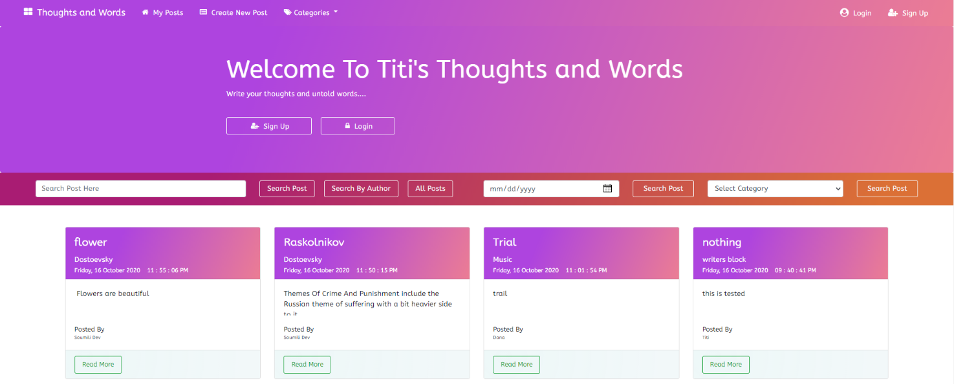Chapter7:Screenshots

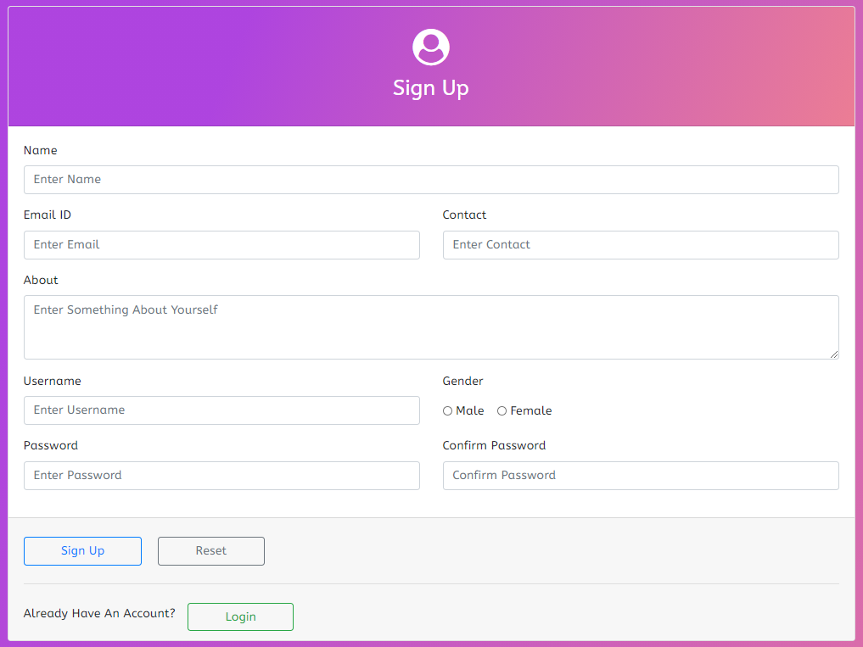

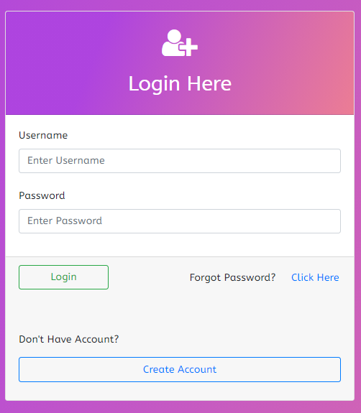

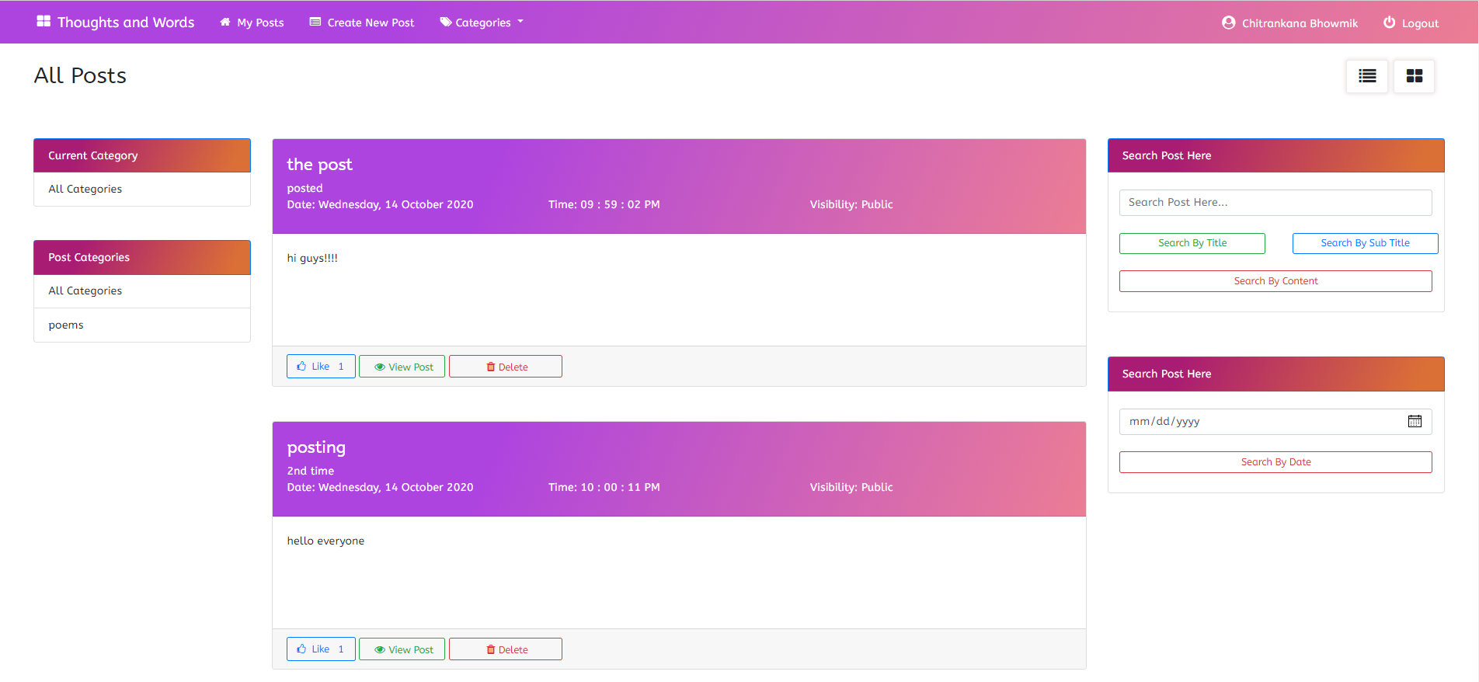

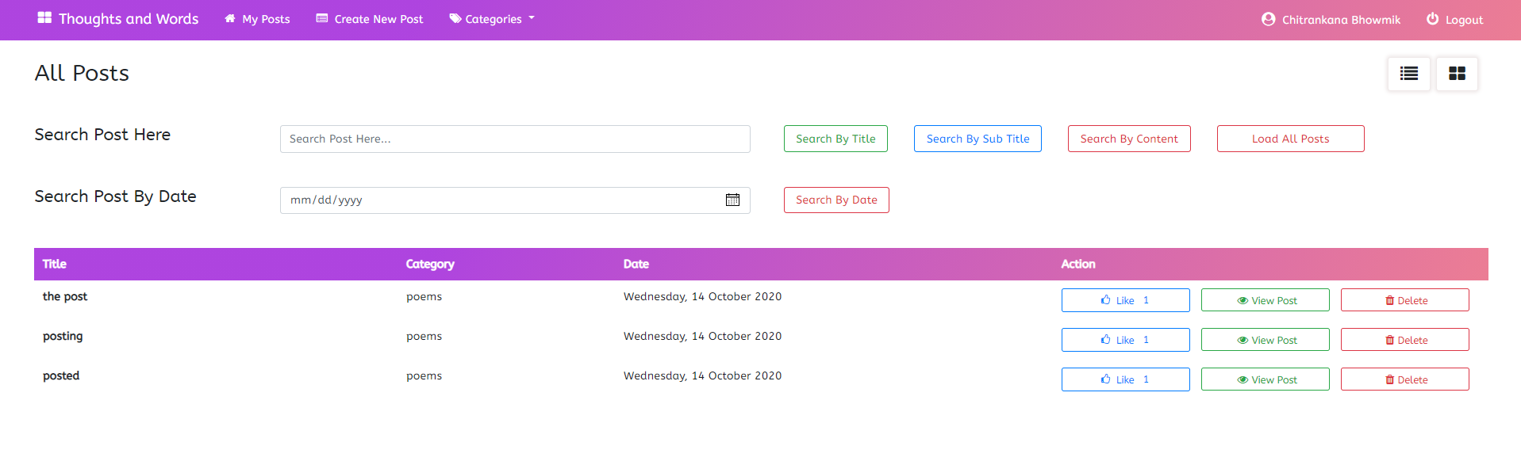

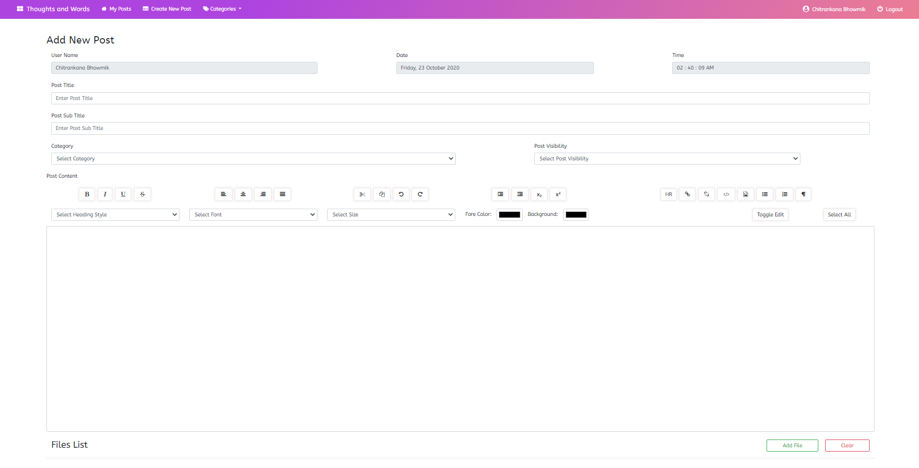

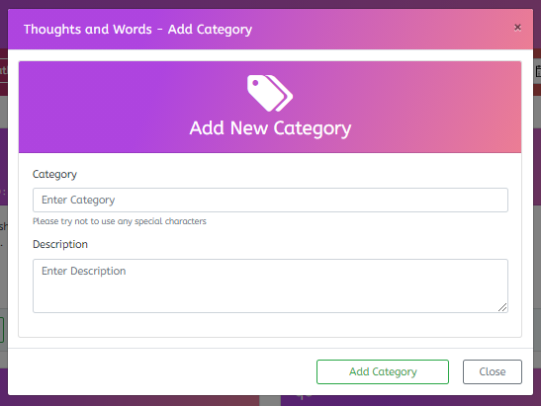

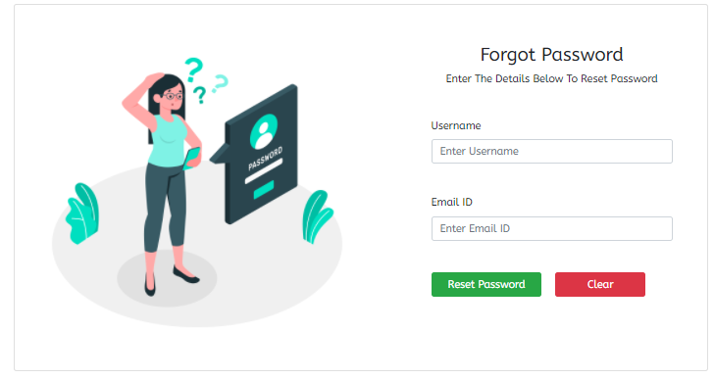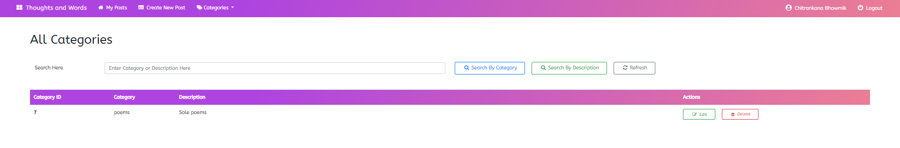

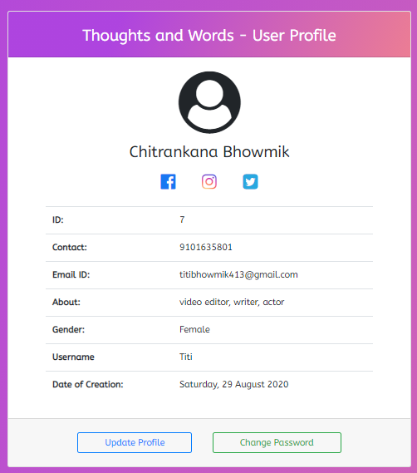

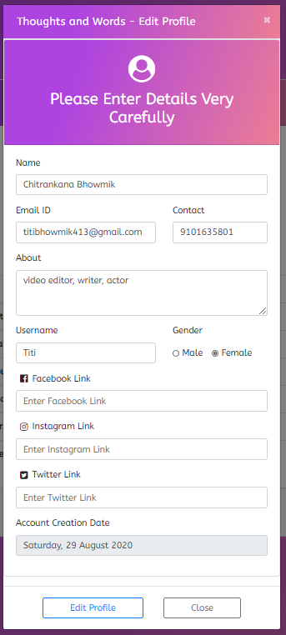

Chapter 8: Project description

8.1    Problem Definition :-

This system developed will reduce the manual work and avoid redundant data. By maintaining the posts manually, then it cannot be shared very easily and the feedbacks are not that easy.

8.2    Project Overview :-

Thoughts and Words basically has only one module which allows an user to write, comment, like and many more.

8.3    Module Description :-

The system should be designed in such a way that only authorized people should be allowed to access modules.

**8.3.1    *User Module :***

**---------------------------------------------------------------------------------------------------------**

1. **Like details :**

In this module reader or another writer that is any user can show their likeness towards the post.

1. **Comment Details :**

In this module reader or another writer that is any user can write comments about the post.

1. **New Post Details :**

In this module the user can create a new post.

Chapter 9: System Maintenance

Software maintenance is far more than finding mistakes. Provision must be made for environment changes which may affect either the computer, or other parts of the computer-based system. Such activity is normally called maintenance. It includes both the improvement of the system functions and the corrections of faults which arise during the operation of a new system. It may involve the continuing involvement of a large proportion of computer Department recourses. The main task may be to adapt existing system in a changing environment. Backup for the entire database files taken and stored storage devices like Flash drives, pen drives and disks so that it is possible to restore the system at the earliest. If theirs is a break down or collage, then the system gives provision to restore database files. Storing data in a Separate secondary device lead to an effective and efficient maintains of the system. The nominated person has sufficient knowledge of the organization computer passed proposed change.

Chapter 10: conclusion

10.1    Conclusion :-

The Thoughts and Words is developed using Netbeans, fully meet the objectives of the system which it has been developed. The system has reached a steady state where almost all bugs have been eliminated. The system is operated at a high level of efficiency and all the user associated with the system understands its advantage. The system solves the problem. It was intended to solve as requirement specification.

      10.2    Scope for Future Development :-

The project has a very vast scope in future. The project can be implemented on intranet in future. Project can be updated in near future as and when requirement for the same arises, as it is very flexible in terms of expansion. With the proposed software of database Space Manager ready and fully functional that client is now able to manage and hence run the entire work in a much better, accurate and error free manner.